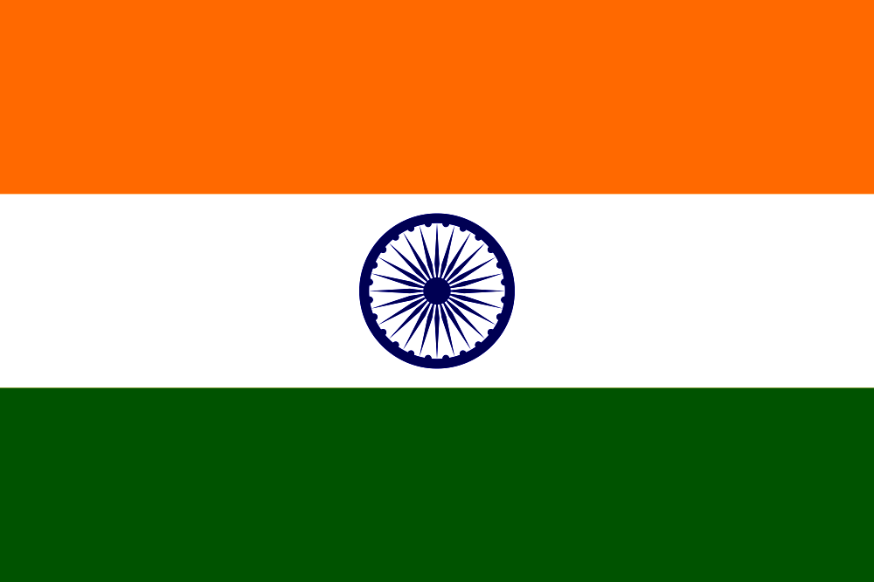

WITH BEST COMPLIMENTS
FROM
INDIAN ARMY

